Milestone-5_Create_onCellEdit_Client_Script

Navigate to Client Scripts:
Go to System UI → Client Scripts in your ServiceNow instance.
Click New to create a new Client Script.
Fill in the details:
Name: Prevent state change via list edit – clearly indicates that the script prevents users from changing the State field directly in a list.
Table: Incident – applies the script only to Incident records.
Type: onCellEdit – runs whenever a field is edited directly in a list view.
Field name: State – the script will monitor changes to the State field.
Active: true – ensures the script is enforced immediately.
Paste the script into the script editor section. The script should prevent unauthorized changes to the State field when editing from the list view.
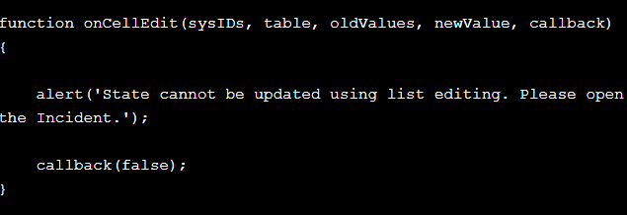
Click Submit to save the Client Script.
Verify: Open an Incident list and try to change the State field directly in the list. The script should block the change as intended.
Click Submit.

